If you would prefer to use the QR code only for the September collection, here it is as a jpeg so that you can add it to your materials:
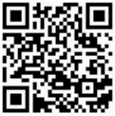

PLEASE NOTE: If you shrink it down to fit into your materials, just make sure that you test it to make sure it is still able to be scanned by your device. If it gets shrunk too small, it will not work.
Thank you for everything you do to support the Clergy Trust collections!

